**For 161:cd DMSTICKET**

**FOR 162: cd DMSTICKETQA**

**Check the tags which is running in 161 admin console. After server restart same tag should run.**

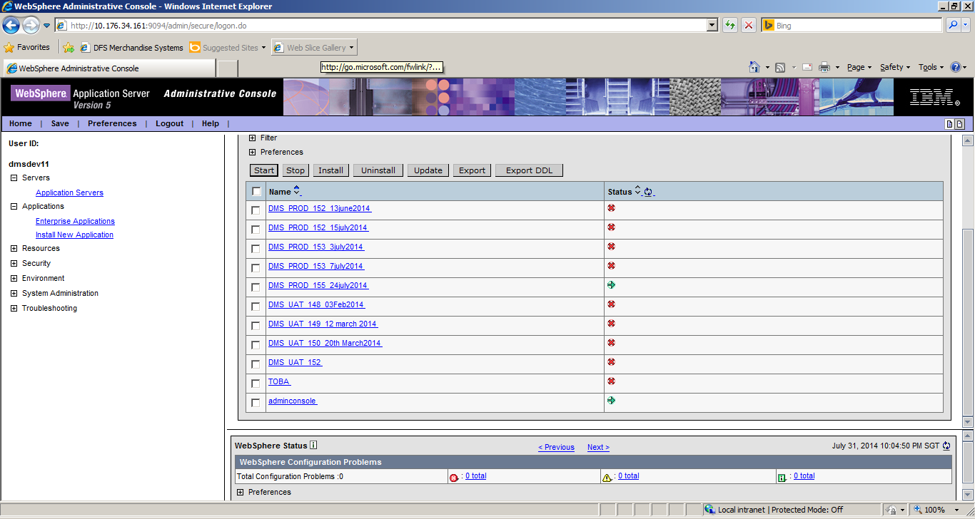

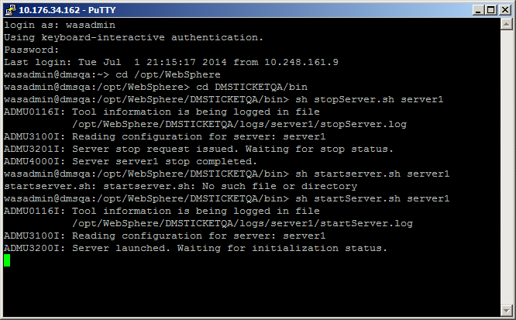

For 161 and 162 it is server1

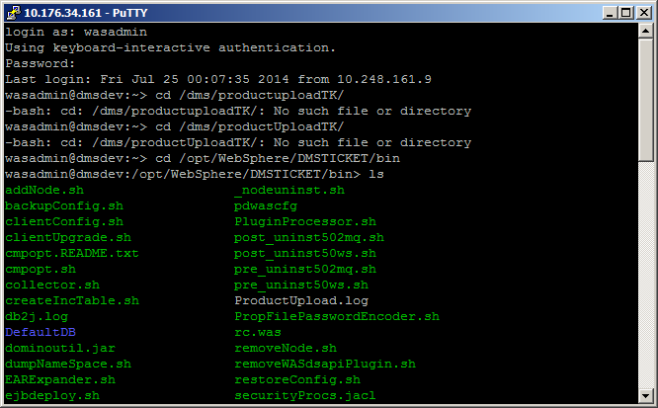

Top

Kill -9 pidnumber

Only one should run

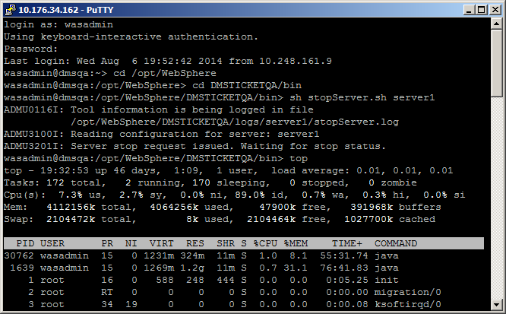

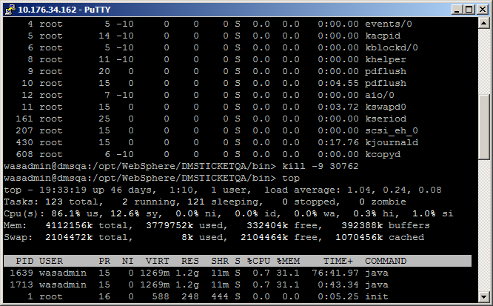

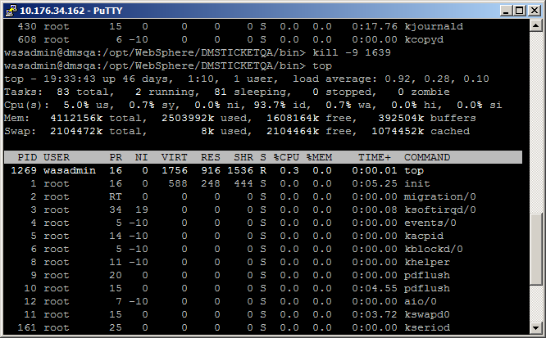

After that stop and start

